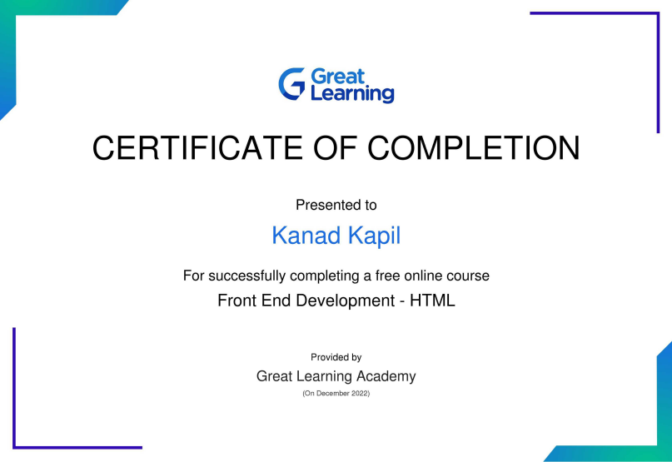To verify this certificate visit verify.mygreatlearning.com/OEEELZYH